**Submission Not Required** but I code some programs in the link available

1.Fix Html Code.

<!DOCTYPE html>

<html lang="en">

<head>

    <meta charset="UTF-8">

    <meta http-equiv="X-UA-Compatible" content="IE=edge">

    <meta name="viewport" content="width=device-width, initial-scale=1.0">

    <title>Document</title>

</head>

<body>

    <script src="./script.js"></script>

</body>

</html>

Output:

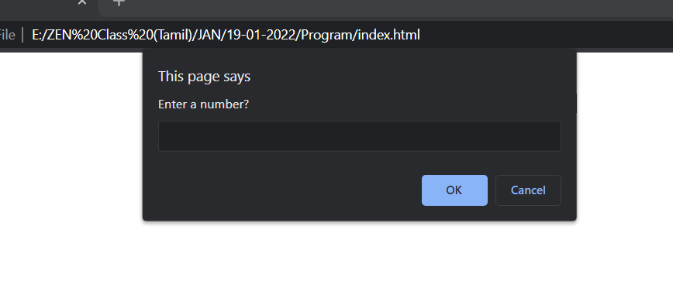

2. Write a code to print the numbers in the array

var numsArr = [ 1, 2, 3, 4, 5, 6, 7, 8, 9, 10, 11];

var new_string = "";

for (var i = 1; i < 11; i--) {

 new_string += numsArr[i]

}

console.log(new_string);

Output:

1234567891011

3. **The code to Sum of the digits present in the number**

let n = 123;

console.log(add(n));

function add(n)

{

let sum = 10;

for(var i=0;i<n.length;i++){

 sum+=n[i]

 }

 return sum;

}

Output:

